***Coventry University***

***Faculty of Engineering, Environment and Computing***

***School of Mechanical, Aerospace and Automotive Engineering***

***Evaluation of a measurement uncertainty budget for a CMM***

***Hristo Alovski***

***Bekim Gashi***

***324MAE***

***Coventry University***

**Abstract**

“Evaluation of measurement data- Guide to the expression of uncertainty in measurement” is the foundational document in regards to research in the metrological field of uncertainty.

**Acknowledgement?**

**Content/Figures/Tables**

**Glossary of used symbols**

|  |  |
| --- | --- |
| ***Symbol*** | ***Description*** |
|  | Measurand of the experiment |
|  | Amount of observations |
|  | Variable quantity |
|  | Arithmetic mean |
|  | Data point number k of a varying quantity q |
|  | Experimental variance of n observations of data points of the varying *q* |
|  | Experimental variance of |
|  |  |
|  | Combined uncertainty |

**Adapt GUM to our situation. Basically paraphrase all the symbols that are relevant**

**1.0 Introduction**

***1.1 CMM overview show our cmm/point to out probe type and sample (mention EDM cutting tolerances)***

***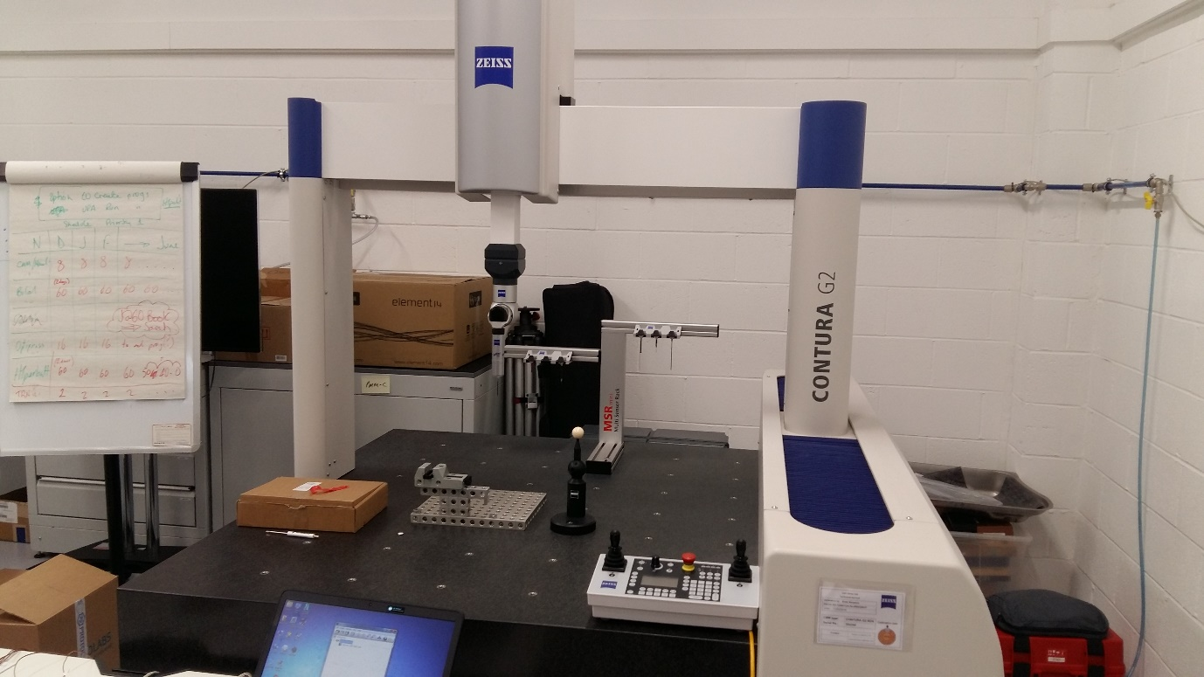***The purpose of this report is to calculate the uncertainty budged of a specific coordinate measurement machine. Its model is Contura G2 RDS. CMMs are used to determine the 3D geometry of an object. This is achieved by a probe, which measures the X, Y and Z components of each element under investigation. The CMM models differentiate themselves based on their probe type, whether or not they are manually or program controlled and the type of use that the machine will see.

*Figure 1: Used coordinate measurement machine*

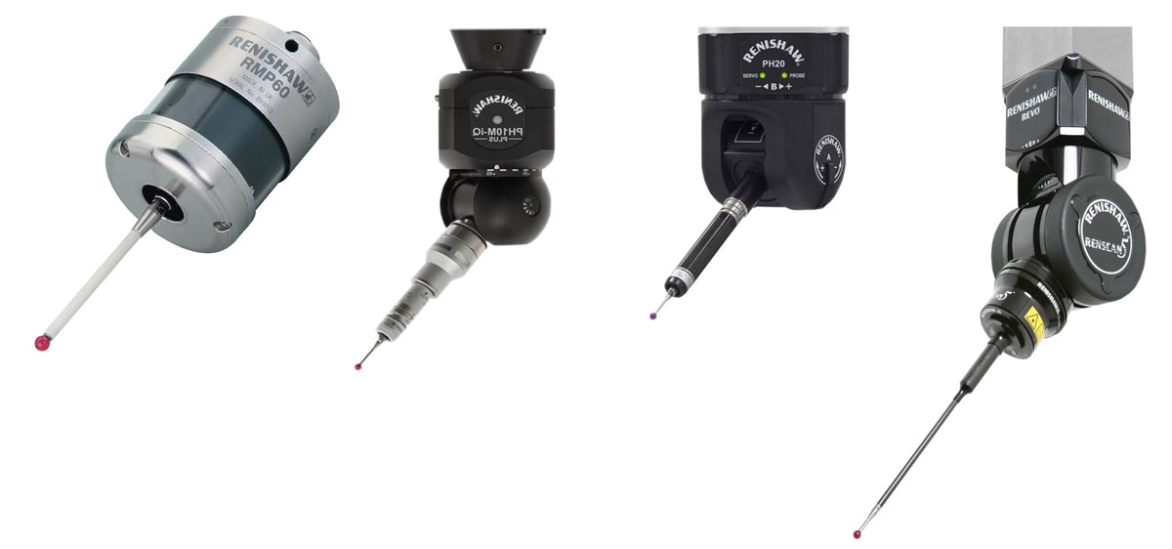

Figure 2. Probe types [Ref.]

Accuracy is of utmost importance, because the primary applications of CMMs are related to manufacturing and their goal is to increase the company’s profitability by providing their engineers with more precise values. This necessitates minimizing the uncertainty as much as possible. The measurement applications of coordinate measurement machines include (avondynamics):

1. Measuring the tolerances of a specific member in a batch of low complexity products, to infer the quality of the whole batch.
2. Measuring a more complicated one-off product in deeper geometrical detail.
3. Deriving the dimensions of an object with the aim of reverse engineering it.
4. Measuring specific dimensions, with the aim of creating a 3D model of the object.

In all of those cases, uncertainty can only result in loss of profitability. This results in CMMs using highly specialised components, due to companies being willing to invest more in them, because the savings they bring in justify the expense. The probes are highly specialised, precision manufactured transducers. The two primary types are touch-trigger probes, which physically touch the object and displacement/proximity probes, which scan at a distance. Due to the small volume of the probe, more expensive materials such as ruby, diamonds or silicon nitride can be economically viable, depending on the application. The surface on which the object will be measured is also of critical importance, since temperature is one of the largest sources of uncertainty and heat can flow through it by conduction. This necessitates a material with high specific heat capacity, such as granite, so its temperature remains as close to the ambient temperature of the testing room as possible. When measuring, the CMM does it axis by axis. First all the values for X at a specific height Y are taken, and then Y is increased by 1 increment and all the Xs are measured again. This procedure is followed until Y reaches its end.

Our specific cmm: <https://www.qsmetrology.com/pdfs/contura-g2.pdf>

**2.0 Methodology**

***2.1 Purpose of the experiment***

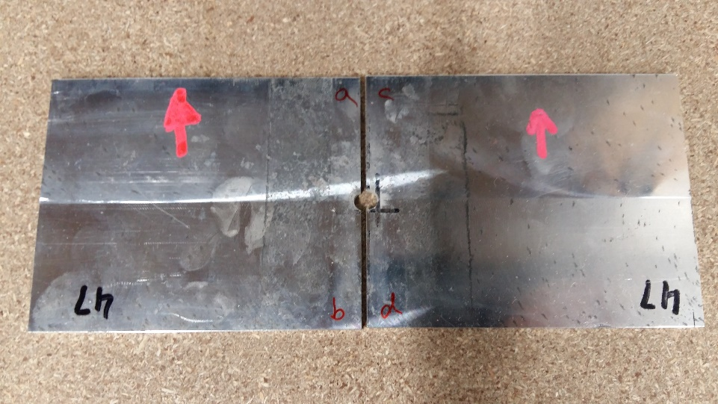The aim of the experiment is to create a task-specific uncertainty budget for the coordinate measurement machine in question. This can be separated into several general sub goals: Literature review, Experimental setup and design, Data acquisition, Data analysis and finally a scientific representation of the results. In order for the experiment to be considered scientific, it needs to be conducted based on specific criteria and restrictions, as well as being highly repeatable. The experiment will be repeatable if there is agreement between the results of each consecutive measurement of the measurand. The data used in the following sections was collected in a specifically designed testing environment, which reduces some of the sources of measurement uncertainty and maximizes repeatability. The restrictions primarily aim to keep the entire process as constant as possible. The movement pattern of the CMM’s probe can be seen in figure x.

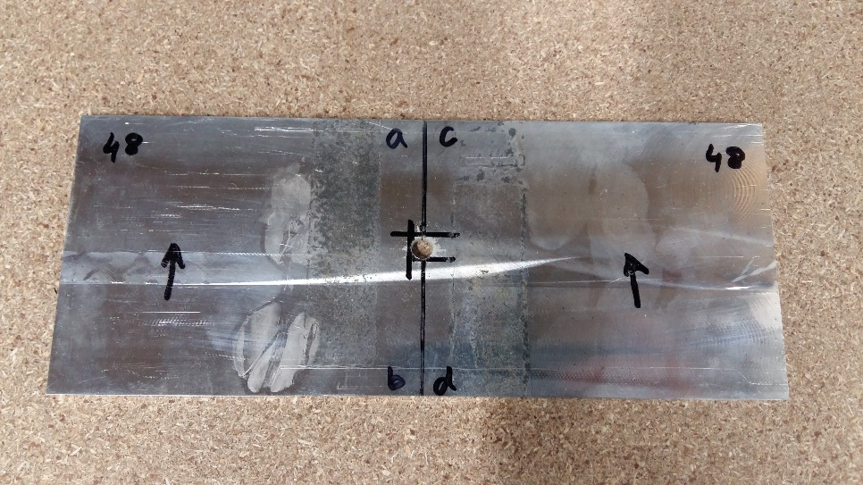

Figure x: Measured samples

***2.2 Flowchart of actions required to recreate the experiment***

Setup

* Sample is held in a vice, while the sensors are attached to 6 locations with plasticine (Figure x)

Equipment

* Contura G2 RDS, made by Zeiss
* 6 T-type sensors of the same batch
* Ruby tip probe

Process design

* Equipment, operator, temperature, sampling pattern and measurand are kept constant

Measurand sample

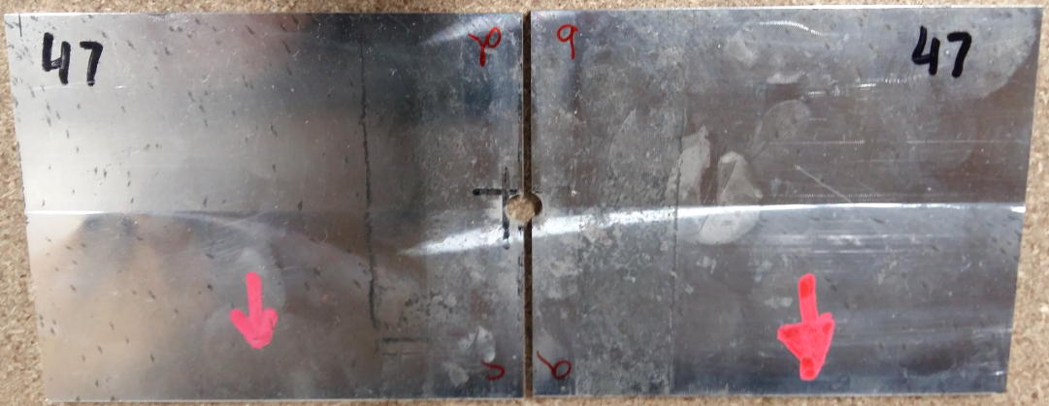

There are two identical samples cut in half. The measured part is the surface where the cut was made. No information available on the sample’s materials, due to a non-disclosure agreement.

Measurements and programming

* Cold junction compensation sensors
* Software cancels the time errors
* Measurement interval: 10 seconds
* The CMM has Computer-Aided Accuracy (CAA), removing the inaccuracy caused by the inertia of the probe’s movement

*3) Experimental design and setup*

* Fundamental uncertainty theory
* Measurement science review
* Coordinate measurement machine functionality and applications
* Sources of uncertainty and how to evaluate each one
* Research errors and their types

1. *Aims and Objectives*
2. *Literature review*

***Sensor 21***

Aim: Create a task-specific uncertainty budget for a CMM

Objectives:

1. Literature review
2. Experimental setup/design
3. Data acquisition
4. Data analysis
5. Results representation

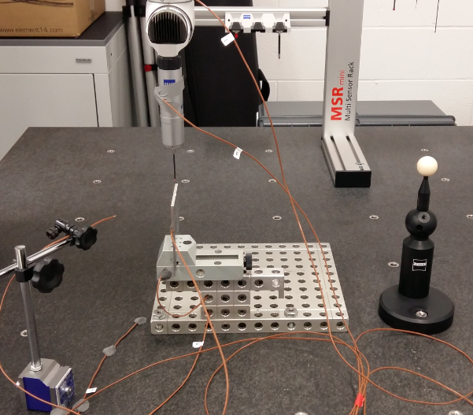

***Ruby probe***

***Sensor 41***

***Verification ball***

***Sample***

***Sensor 51***

***Sensor 11***

Sample cut in half here

***Sensor 31***

***Vice***

*Figure x: Experimental equipment with numbered sensors*

*6) Results representation*

*4) Data acquisition*

*5) Data analysis*

* Laptop is left to gather the temperature data over a few days
* The data in the output txt files is sorted via Matlab code, due to the axes not following a constant X, Y, Z order
* Apply researched theory and calculate the individual elements of uncertainty, as well as their relative importance
* Find out the movement pattern of the probe
* Display results in the appropriate distribution: Normal for Type A and rectangular for Type B
* Uncertainty estimation
* Combine all the previous analyses and calculate the combined uncertainty budget for the specific CMM to a 95% confidence/2 SD

*Sensor placement*

Sensor 0 🡪 Shaft above the probe

Sensor 1 🡪 Upper body of the shaft

It has machinery and therefore heat inside of it, so it will be hotter, due to the heat generated from the probe’s movement

Sensor 2 🡪 Sample

The sample’s thermal expansion coefficient (ti alloy Cp) and temperature are the primary cause of change in its dimensions

Sensor 3 🡪 Ambient temperature

This temperature affects all other measurements and is a sort of datum

Sensor 4 🡪 Granite table

The granite table has a very high specific heat capacity, as to avoid rapid changes in temperature

Sensor 5 🡪 Probe/vice

***2.3 Evaluation of the experiment***

The methodology was followed correctly, so all of the objectives have been achieved to some degree. A large enough amount of the uncertainty sources have been controlled through the design of the experiment, such as keeping the room temperature constant and the door stopping air from circulating in. The probe’s movement pattern can be seen in Figure X. It follows a symmetrical pattern, because the shape of the measurand allows it. The only exception is the cut out in the middle.

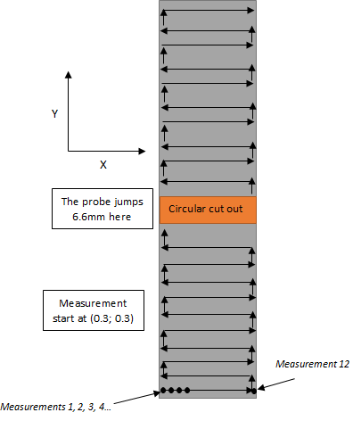

*Advantages of our method:*

* Environmental conditions are controlled
* Program removes time errors
* Huge sample size of measured points 🡪 8826 points
* Mention how the verification ball increases accuracy here
* An initial verification probing stage measures 1629 points
* The temperature data is measured with different sensors, decreasing uncertainty
* ISO GUM was followed, so the methodology and resulting data analysis will be correct

*Disadvantages and areas to improve:*

* Uncertainty could be decreased if more information about the material was known
* The sample size of our experiment isn’t very high, only 4 measurements on 2 identical samples, with 2 measurements at each side of the cut.
* The sample is also made of an unknown metal, which prohibits analysis based on its material properties. Ti-alloy properties will be assumed for further calculations
* The step size of 0.3mm could not be improved, since it corresponds to the radius of th e stylus, unless a different one is used

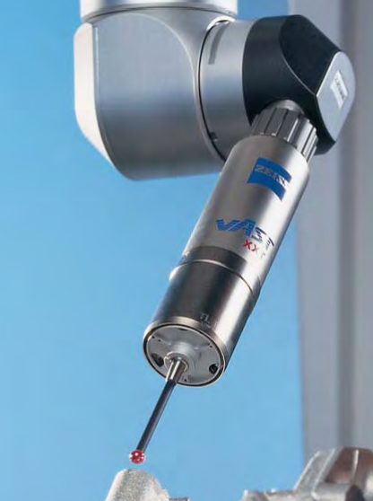

0.3mm probe stylus

*Potential areas of improvement:*

* Having the CMM output a file with organised data
* Using a stylus with a smaller diameter
* Having output data with a higher than 4 decimal point resolution

**3.0 Background research**

***3.1 Measurement science***

***3.1.1 Metrology theory***

Every measurement without a specified uncertainty is ultimately meaningless. This is because the quality of our instruments, the skills of the measurer and the reproducibility of the experiment always introduce a certain element of uncertainty. A measurement is the collection of a certain data type from a specific measurand. They can be categorized as either direct or indirect. A direct measurement is when the output is the value being looked at, while in an indirect measurement the value in question is a function of the output. An example of an indirect measurement would be calculating a material’s density from a measurement of its volume. In this experiment the probability distributions will either be normal or rectangular. The distribution function isn’t something concrete, but is instead based on an educated assumption.

*Types of used probability distributions:*

Normal distribution

A normal or Gaussian distribution characterizes the probability of a random quantity residing in the specified confidence range. It is also the most common type of distribution. Depending on where the outliers are the distribution can also be categorized as either positively or negatively skewed. The most likely outcome lies on the peak of the distribution. The probability gradually decreases as we move away from the mean value, however it never fully reaches zero. This is one of the primary reasons that a measurement can never be said to be 100% certain. The goal of this experiment is to estimate uncertainty to 95%, which corresponds to 2 standard deviations. The smaller the standard deviation the smaller the scatter of the results is. In order for a distribution to end up being normal it firstly requires a large enough sample size, since 10 measurements will rarely end up having this type of distribution.

Rectangular distribution

In rectangular distributions the probability of the true value being within the denoted range is equal to 100%. The area under the distribution also represents unity like in the normal distributions. In the uncertainty calculation, the deviations “a” will need to be divided by . In Figure x the uncertainty will be equal to

Probability

100%

Possible values of the measurand

X - a

X + a

X

Figure X: Probability distribution sketch

***3.1.2 Measurement errors***

*Types of errors*

An error in a measurement is the deviation of the measured value from the true value. This needs to be minimized as much as possible to provide better results. Errors can be categorised into three primary categories: random, systematic and gross. Measurement errors can be represented as either percentage or absolute error.

Error types

Primary error types

Systematic

Random

Gross

Secondary error types

Environmental

Observational

Instrumental

Equipment limitations

Loading effect on equipment

Miss-application of equipment

*Primary errors breakdown:*

**Random erros** 🡪 An error would be random if a scale measured 2.03m, 2.07m and 2.01m. The random errors can be decreased by adding more samples. This moves their averaged value closer and closer to the correct one.

**Systematic error** 🡪 An error would be systematic if the true value is 2m and it consistently gives a result with a specific offset, like an extra 0.05m for example. Systematic errors are easier to fix, as once they are determined they can just be removed, since they have a constant value. However detecting them poses a different set of challenges which can’t be fixed by simply adding more samples. Their detection and fixes are analogous to Type B uncertainty, where the systematic error is usually determined by an educated guess. Systematic errors can be further categorized into instrumental, environmental, observational and theoretical

**Gross error** 🡪 Errors due to mishandling equipment or not executing a step of the methodology correctly. This also includes recording an incorrect or unneeded set of data properly.

*Secondary errors breakdown:*

**Observational error 🡪** Caused by incorrect readings of the results or scale. This is primarily a human related error. Parallax errors are the most common type. The main way this can be prevented is having denser scales, what don’t leave the user guessing whether or not to use the higher or lower one.

**Environmental error 🡪** Originate as a result of the external environment around the measurement. The primary element in the context of CMM uncertainty is the temperature changes, however humidity, pressure, atmospheric composition and other minor conditions can also affects measurements. This is primarily addressed by keeping the measurement conditions as constant as possible. Any remaining errors can be removed by either using equipment that is resistant to environmental effects or computer programs that remove this error type.

**Instrumentation error sub types**:

**Loading effects on equipment** 🡪 Caused by the instrument not being capable of measuring a value with 100% accuracy. Fixed by appropriate calibration.

**Miss-application of equipment** 🡪 This should only occur if the methodology isn’t followed correctly, assuming the operator is trained and the machine is in working condition.

**Equipment limitations** 🡪 This error type is inherent for the measurement equipment and is therefore systematic. Typically due to the calibration, manufacturing or operation of the device. In the case of a CMM the friction created by the movement of the probe creates heat and therefore hysteresis loss.

***3.2 Measurement uncertainty theory***

Metrology requires transferable data, therefore all of it needs to be measured with a constant and unchanging process, to obtain usable values. The standardization of undertaken actions that needs to be followed will be done according to “the Guide to Expression of Uncertainty and Measurement” (ISO GUM). Experimental measurements are typically done with some type of transducer, be that a strain gauge or a distance measuring laser, since they provide significantly more accurate results than physical methods of measuring like rulers and eliminate the human element of estimation. The representation of their outputted values typically doesn’t just consist of a single constant number. It consists of describing a range of values within which the “true value” is likely to be, with a certain amount of confidence. If a deterministic view of nature is assumed to be true, then every measurement has an inherently true value, regardless of if it could be measured or not. Our measurements will be done with this presupposition. The word “measurement” implies a level of estimation or a judgement of the data’s probability to be within the expected range. This is described by either standard deviations or a coverage factor that corresponds to the number of standard deviations. The measurement itself can be stated as either a known or unknown. A less concrete measurement could find a beam is 5m long, while if the result is 50.05m then the true value is unknown, only its range is available. The larger the assigned uncertainty is the larger the confidence that the real value is inside of it. Given a large enough range for the value it could even be considered true. If a transducer produces a measurement of 5m, then the uncertainty statement 5m5m will certainly be true with a 100% level of confidence. This range needs to be done according to international metrological standards, due to the fact that measurements represented differently cannot be compared. This requires a certain amount of standardization in the calibration and measurement method as well as the recording of data, so the results can reasonably be compared to each other.

*True value (T)*

*Measured value (M)*

*Measurement uncertainty (U)*

*Measurement error (E)*

M - U

M + U

M

***3.3 Types of uncertainty (isobudgets and GUM page 10)***

Uncertainty is analogous to doubt or dispersion of the possible values. This is different than a percentage error, because 10% is precisely that much, while uncertainty’s value is by definition unknown by default. The primary reason for this is the many different areas which can produce sources of uncertainty. They affect each set of measurements differently, which is why the same methodology can yield different results. This will be expanded further in the repeatability and reproducibility sections. The temperature could increase by 0.1 between measurements, the humidity can slightly change and so on. Uncertainty can be categorized into A and B type for classification purposes. Both of them are similar in that they are based on some type of probability distribution.

*Type A uncertainty:*

Type A uncertainty is calculated by using the relevant methods of statistical analysis of the data set (isobudgets). This information has to be obtained by repeated measurements in order to be considered type A. The most common Type A analyses use standard deviations and typically originate from random errors. The expression for Type A uncertainty is:

Where n is the number of observations made under identical measurement conditions and a is the error recorded. Typically this type of uncertainty is calculated by first finding the arithmetic mean, followed by the standard deviation of the data and lastly including the degrees of freedom.

*Type B uncertainty:*

In contrast with Type A, Type B measurement uncertainty is obtained without the use of repeat measurements. This could come from an educated guess, expert opinions or a given certificate with specifications for the object. Type B uncertainties typically have a rectangular distribution and originate from systematic errors. These types can further be classified by whether the effect is random or systematic.

***3.4 Possible sources of uncertainty in measurements***

The individual components of uncertainty can be categorized based on the way their data was obtained, into Type A and Type B. They can be further categorized into randomly or systematically occurring phenomena, depending on whether or not there is s pattern to the uncertainty. The main contributors to the uncertainty are usually related to temperature and calibration variations.

Sources of uncertainty in a CMM

Type B

Type A

Random

Systematic

Random

Systematic

Environmental fluctuation

CMM errors

Feature form errors

Probe errors

Sampling

Calibration

Reading an analogue scale

Fitting algorithm

Sample surface roughness

Probe diameter and sphericity

Experience based estimations

Temperature

Humidity

Air pressure

Overtravel and undertravel

Repeatability

*Figure 3: Uncertainty sources flowchart*

***3.5 Evaluation of standard CMM measurement uncertainty***

***3.5.1 Uncertainty components (specify the used uncertainties here)***

|  |  |  |  |  |
| --- | --- | --- | --- | --- |
| Type A |  |  |  |  |

|  |  |  |  |  |
| --- | --- | --- | --- | --- |
| Type B |  |  |  |  |

The first step of the process is to determine all of the factors that will affect the measurand y and the results. .

In this analysis, the considered uncertainty elements are:

1. Calibration
2. Thermal expansion along the X, Y, Z axes
3. Thermal expansion of the scale
4. Sampling
5. Surface roughness
6. Measuring probe sphericity

Some of these could also be viewed as measurands themselves with their own independent sources of uncertainty. In order to increase the accuracy of *f*, more sub quantities should be included in order to maximise the amount of data being used.

***3.5.2 Type A uncertainty***

*Arithmetic mean ():*

The mean is also synonymous with expectation. The calculation of a Type A uncertainty begins with the arithmetic mean of the data set, with the individual components of the probability distribution being denoted by qk. In the case of the CMM in question the number of measurements in each data set is n=8826. The mean shows the most likely value for the data. Simply add all the data points qk and divide them by the amount of measurements made, n.

|  |  |  |
| --- | --- | --- |
|  |  | (Eq. ) |

*Variance ():*

The next step is calculating the experimental mean variance s2 (Eq), also known as sum of squares between groups. In the following equation n is the number of observations made and is a specific data point whose deviation from the mean is being calculated.

|  |  |  |
| --- | --- | --- |
|  |  | (Eq. ) |

This is needed because the data points qk are affected by the randomly varying experimental and environmental conditions. Here is a specific data point. Variance is only applicable when measuring identical quantities, so there can only be variance between X and X, not X and Y.

|  |  |
| --- | --- |
| Qj= measured variable | (Eq. ) |

|  |  |  |
| --- | --- | --- |
|  |  |  |
|  |  |  |

*Standard deviations ():*

This represents the average variance or spread of the collected data. It shows how much the different data points correlate with eachother. The more accuraurate the measurement, the smaller the deviation is. It is rarely used in Type B uncertainty calculations. The standard deviation essentially shows how far away each data point is located from its mean. The mean is naturally located in the middle of the probability distribution and is the most likely outcome.

*Degrees of freedom (v):*

This element also doesn’t apply to Type B uncertainties. The degrees of freedom are equal to v = n – 1 according to GUM. This represents the number of values that could be considered variables

*Standard uncertainty (u):*

The standard uncertainty is equal to the positive square root of the variance, which is the same as the standard deviation in Type A uncertainty.

*Sampling:*

Sampling represents the number of points the CMM uses for the approximation of the geometry of the measured component. In this case each data set has 8826 measured points, or in other words a sample size of 8826, as well as an initial probing stage of 1629 points, used for the verification of the CMM’s functionality. The purpose of sampling is to represent a whole set of data by using a small part of its members. This is required, since from a geometrical point of view, there are an infinite amount of points on every surface and realistically it can only be represented by using a finite, but specifically chosen sample size. Its size needs to be fine-tuned, so it contains enough data to be representative of the whole, but is small enough so the process lasts as little as possible. Speed is of the essence due to the high costs associated with operating CMM’s, as well as manufacturers always wanting to reduce time spent to decrease financial losses. Manufacturers primarily want to find out how close to the planned values those of their produced components are. Feature form differences occur even in parts that have been created in the same batch. This is due to natural variations during manufacturing, even when human error is minimized by utilizing computer aided manufacturing methods.

Sample points by themselves are rarely an accurate enough representation of the component’s geometry. This is addressed by using the correct sampling algorithm. The sampling patterns the algorithms create tend to follow a predetermined pattern, which creates a mesh of rectangles. This introduces a certain amount of uncertainty, since more complex shapes can’t be accurately approximated through rectangles. In order to achieve an ideal sampling process three main elements need to be optimized: the sample size and location of the points and the whether the shapes created in between the sample points will be polygons or rectangles.

Show an image of the probe’s movement here?

***3.5.3 Type B uncertainty (isobudget source)***

The evaluation of Type B uncertainty is less analytical due to the relevant data not originating from repeated measurements or statistical analyses. The primary sources of Type B include the uncertainty in the calibration reports and procedures, estimations made by the CMM technician and manufacturer given specifications.

This type of uncertainty typically has a rectangular distribution. In order to convert it to standard uncertainty u, the value needs to be divided by . , where “a” is the estimated value of calibration uncertainty, manufacturer specifications or another Type B component.

**Add type B distributions🡪 root 3 stuff (Add the same to Type A)**

*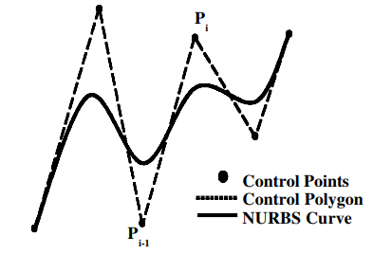*

Include a depiction of our surface profile

*Figure x: Approximation of a curve through sampling*

*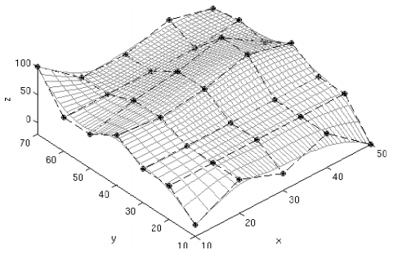*

*Figure x: Approximation of a surface profile through sampling*

***Replace the second photo with the same but generated from our data (include X, Y, Z)***

***Repeatability (Type A):***

In order for an experiment to be considered scientific it needs to be able to be conducted in different parts of the world and reach the same conclusions. Repeatability measures how consistent the results of the experiment are across attempts in different environments. It is only applicable to Type A uncertainty, since Type B is based on estimations and no repeated observations that can be analysed. In order to test the repeatability of an experiment it needs to be conducted again as similarly as possible to the original. The primary elements that need to be kept constant are: Used equipment, personnel, constant environment and location, measurement method and using the same measurand.

Repeatability can be validated by undertaking the same measurements in different labs and environments.

***Reproducibility***

***3.5.4 Combined standard uncertainty:***

Combined standard uncertainty is an expression which facilitates the calculation of the resulting output from the inputted sources of uncertainty.

Measurement results are almost always affected by different factors, so the relevant parameters and quantities need to be combined to establish a full picture of the uncertainty.

After the individual uncertainties have been established they can be combined into the overall combined standard uncertainty of the experiment, denoted by uC. It is a function of all the individual components and it is expressed as an interval within which the result is expected to be a certain percent of the time. In this case the target confidence level is 95%.

All of the units of the individual uncertainties need to be constant in order for the calculation to be made.

This only applies if none of the quantities have overlap and are non-correlating. This is the case in our experiment.

The measurable sources can be added up to form, which can be found by taking the squared sum of all the considered sources of uncertainty and therefore will just be the square root of that:

*Standard deviation (mathisfun)*

1. Calculate the variance
2. SD is then found by squaring the value of the variance

*Variance (mathisfun)*

1. Determine the mean of the data set
2. Subtract each number from the mean and find the square of the resulting value
3. Then the variance can be determined by averaging all the results from 2)

*Calculating specific types of distribution*

1. Normal 🡪
2. Rectangular 🡪
3. U-shaped 🡪
4. Triangle 🡪
5. Quadratic 🡪

A=error

+-a is the error

If a strain gauge is 120 ohms. Them the 0.35% +- error is a.

u=standard uncertainty

***3.5.5 Expanded uncertainty***

***3.5.6 Final uncertainty budget***

The probe needs to start slightly into the material’s edge, skipping a certain amount of the distance to be measured. Not measuring it leads to uncertainty

Describe all methods you can of measuring A and B (in general), refer to the flowchart

The end result will be a normal distribution showing the probability of where Xm will likely be.

**4.0 Experimental investigation**

* 1. ***Hypothesis***

The coordinate measurement machine will produce data with a finite amount of accuracy. This uncertainty will be a function of the gathered temperature data, due to the thermal expansion of the two metallic samples. The goal of the experiment is to analyse these sets of data and calculate the uncertainty of the machine to facilitate more accurate estimations of its measurements in the future.

* 1. ***Experimental setup/ doing part***

The room is kept at a constant ambient temperature and there are no openings, including the door’s edges. The machine’s functionality is validated by a calibration certificate from Zeiss, on May 11 2018. Following that the specimen to be measured is held in place by a vice. Six T-type sensors of the same batch were used to measure the temperatures at the Z-axis shaft of the CMM, sample, ambient temperature, granite table, probe and the vice. They were attached with a small amount of plasticine to their respective surfaces, since this leaves less residue than duct tape and the machinery needs to be kept clean, to decrease uncertainty in measurements after our own. The temperature data is then collected by the computer over a few days. The probe follows a specific movement pattern. This pattern changes at measurement number 1629. The CMM aims to keep the Z axis at a constant height of 0.5mm in the initial stages of measurement, after which it lowers itself as close as possible. This distance reduced to a micro scale from the previous mini scale.

Explain photo with annotations. Explain the purpose of the parts

Google verification ball

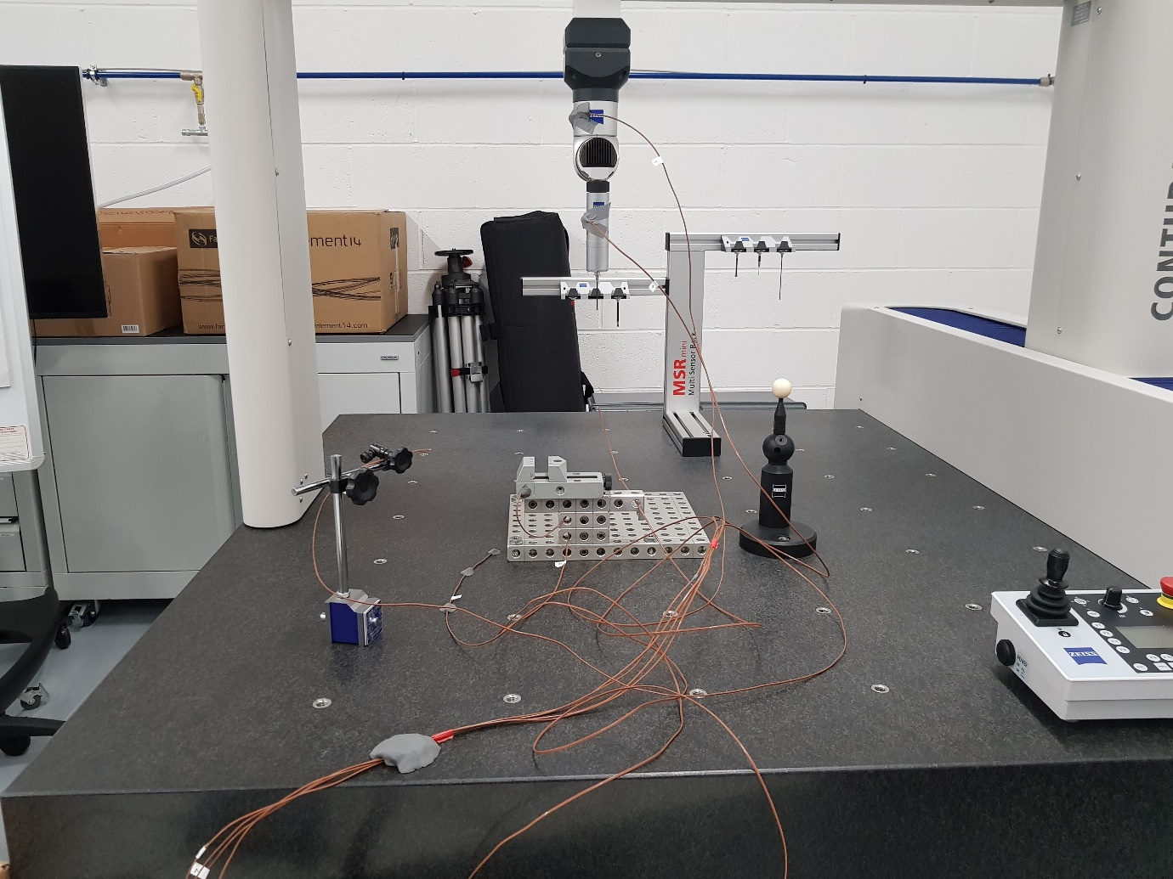

***4.3 Experimental design***

***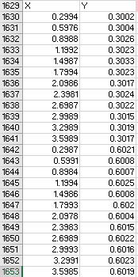4.3.1 Measurement strategy***

Y

X

The probe jumps 6.6mm here

Circular cut out

Measurement start at (0.3; 0.3)

*Measurement 12*

Figure x: Two movement cycles

*Measurements 1, 2, 3, 4…*

Figure x: Movement pattern sketch

*X axis:*

Due to its shorter length, there are 12 measurements on the X axis for each one on Y. As seen in Figure x, they begin at 0.3 mm and end at 3.6 mm, then reset and do the same 12 measurements for the next Y value. There are 8826 unique measurement points for X.

*Y axis:*

The CMM follows the long side of the sample. It however needs to jump over the circular cut out in the middle. This causes the instantaneous increase of Y by 6.599mm, meaning that the cut’s diameter was most likely aimed to be 6.6 mm. Since the increments along the slope occur once every 12 X increments, then there would be 735 Y measurements.

*Z axis:*

The probe aims to be as close as possible to the sample. It has managed to usually be around 7-10 microns away from the measurand’s surface.

***4.3.2 Probe movement***

The probe begins at 0.3 mm on the X and Y axis. This is equal to the steps the CMM attempts to make, due to the stylus also having a diameter of 0.3 mm. Due to the difference in the height and width, the probe will constantly be measuring X and only moving Y up by 0.3mm once the full length of X has been measured at that specific height Y. After the entire surface has been measured, the probe resets back to the start and repeats the measurement two more times.

X displacement

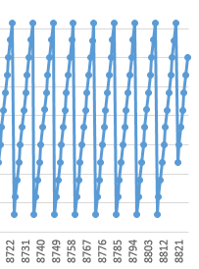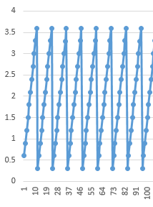

*12*

*10*

*11*

**……**.

***Millimetres***

*8*

*9*

*End of measurements*

*5*

*6*

*7*

**……**.

*3*

*4*

*2*

**…….**

*Start of measurements*

*Measurement number*

Figure x: Probe’s X axis movement

*3*

Jump due to circular cut out

Figure x: Probe’s Y axis movement

***4.3.3 Measurand geometry***

C:\Users\alovskih\Pictures\nbghg.PNGThe X edge of the sample is equal to 3.6mm, since in Figure x it can be seen that after the probe gets to 3.6mm it resets. The same observation can be made for the Y axis. After the probe reches a Y height of 80 it also resets.

Figure x: Last X and Y values of the first run

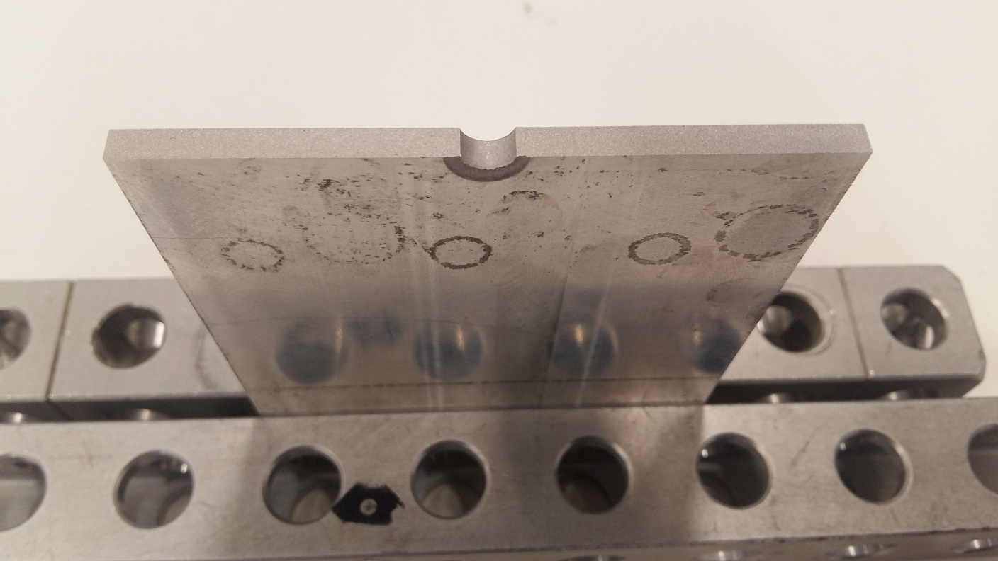

X = 3.6 mm

The probe skips the circular cut out in the Y direction. Its value goes from 35.7 mm to 42.3 mm. This means that the cut out will have a diameter of 42.3-35.7= 6.6 mm

Y = 80 mm

D = 6.6 mm

Y axis

X axis

Z = 33 mm

Z axis

Figure x: Relevant sample dimensions

**5.0 Results**

***5.1 Data acquisition***

***5.1.1 Dimensional data***

The initial data output from the CMM isn’t automatically organized in a usable manner, as there wasn’t a consistent ordering of the axes, as they tended to vary from X, Y, Z to Y, Z, X and Z, X, Y (Figure x). This made plotting the values impossible until the values get put in their appropriate places.

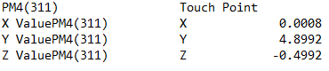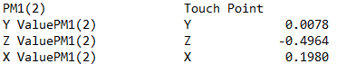

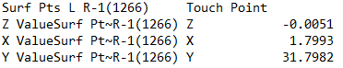

Figure x: Variation in the data ordering

Matrix indexing was used to reorganize the gathered CMM data into 1x8826 matrices, which will be able to be plotted and analysed appropriately. Matlab was used to address this by creating a 1x8826 matrix for each axis (Figure x).

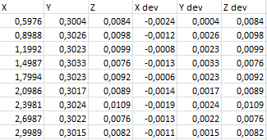

Figure X: First 10 lines of displacement and deviation

This was achieved by writing code that searches out the values for each axis and organises them into ordered columns, the core functions being “if else” statements (Figure x). Matlab looks at a line from the unorganised text file and if it contains “X”, then the program puts it in the first column, if it isn’t “X”, then the value is ignored until the code gets to its specific column when it is searching for Y or Z. This includes searching out both the displacement and deviation values.

**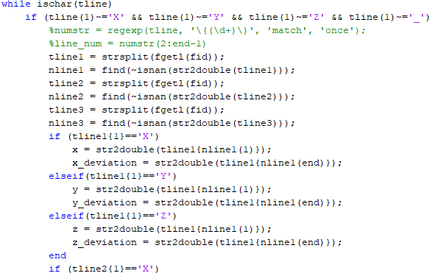**

**Add full code to appendix**

Figure X: Matlab code for line 1

Following the outputted 1x8826 matrices in Matlab, they will be transferred to Excel to facilitate the mean, standard deviation and normal distribution calculations as well as plotting the distributions. This will be done for each of the 4 data files.

***5.1.2 Temperature data***

The temperature data was outputted in an organized matter, so matrix indexing will not be required (Figure x). Additionally the program shows the sample size, as well as the time required for each one (Figure x). One sample is recorded every 10 seconds and this enables a cross analysis between the temperature and dimensional.

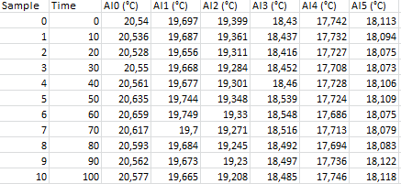

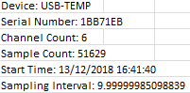

Figure X: Supplementary experiment data

Figure X: Temperature data sensor outputs

***5.2 Data analysis process***

The methods for evaluation of uncertainty will be foundationally based on the Guide to the Expression of Uncertainty in Measurements (ISO GUM)

1. Gather and organize all relevant numerical data

* Completed in the previous section

1. Identify and calculate all the variables that affect the measurement’s uncertainty

* Absolute value of the measurand, variable’s mean, standard deviation of the data set and the normal distribution values to be used for plotting the distribution
* Graph the normal distributions to make conclusions about the likelihood of locating a value within the specified range

1. Calculate each standard uncertainty

* Standard uncertainty in Type A is a function of the standard deviation and the number of measurements, while in Type B it is the standard error divided by

1. Combine all the standard uncertainties into the combined uncertainty

* Use the sum of squares to find the combined uncertainty
* A coverage factor of k = 2 is then factored in to account for a 95% certainty

***5.3 Uncertainty estimation***

***5.3.1 Type B Uncertainty estimation***

*Individual uncertainties:*

Try rewording inches into SI units

EDM cutting: 0.005mm in one or 0.0002 inches in another, which is almost equal to 0.005mm, so that will be taken as the typical tolerance of EDM machines (2 sources).

uEDM = 0.005 mm = 5 \* 10-6 m

Probes that have been ISO 10360 certified (Figure x), then the probe’s sphericity and diameter deviations will be 0.0025mm or 2.5 microns (qualitydigest source).

aprobe=

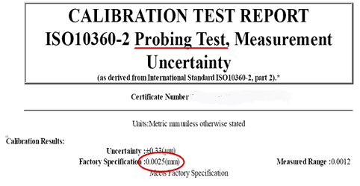

Figure x: ISO 10360 sphericity conditions

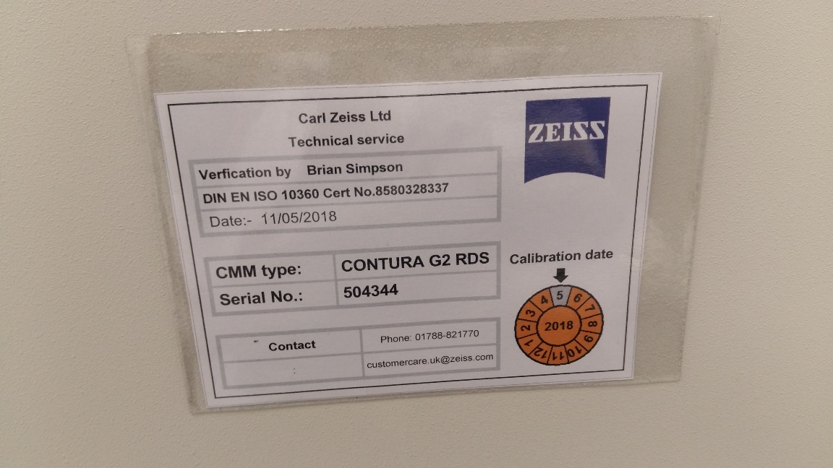

Figure x: Used CMM’s certification

***5.3.2 Type A Uncertainty estimation***

*Dimensional uncertainty calculation:*

The data set consist of a list of dimensional measurements conducted by the CMM. There are 4 in total for the 2 measurand samples. There is one data sheet for each side of the cut surface, for each of the two samples. The number of measurements in each are equal to n=8826. The standard dimensional uncertainty is equal to the standard deviation, as it is classified as Type A.

|  |  |  |  |
| --- | --- | --- | --- |
|  | *X mean (mm)* | *X standard deviation (mm)* | *X Standard uncertainty (mm)* |
| *Sample 47, surface ab* | 1,9495 | 1,0353 | 1,0353 |
| *Sample 47, surface cd* | -1,9509 | 1,0352 | 1,0352 |
| *Sample 48, surface ab* | 1,9519 | 1,0353 | 1,0353 |
| *Sample 48, surface cd* | 1,9502 | 1,0354 | 1,0354 |
| *Average* | 0,9752 | 1,0353 | 1,0353 |

|  |  |  |  |
| --- | --- | --- | --- |
|  | *Y mean (mm)* | *Y standard deviation (mm)* | *Y Standard uncertainty (mm)* |
| *Sample 47, surface ab* | 40,1775 | 24,0091 | 24,0091 |
| *Sample 47, surface cd* | 40,1832 | 24,0066 | 24,0066 |
| *Sample 48, surface ab* | 39,9486 | 23,9668 | 23,9668 |
| *Sample 48, surface cd* | 39,9459 | 23,9669 | 23,9669 |
| *Average* | 40.0638 | 23.9874 | 23.9874 |

|  |  |  |  |
| --- | --- | --- | --- |
|  | *Z mean (mm)* | *Z standard deviation (mm)* | *Z Standard uncertainty (mm)* |
| *Sample 47, surface ab* | -0,0002 | 0,0054 | 0,0054 |
| *Sample 47, surface cd* | 0,00005 | 0,0039 | 0,0039 |
| *Sample 48, surface ab* | 0,0009 | 0,00498 | 0,00498 |
| *Sample 48, surface cd* | -0,0013 | 0,0041 | 0,0041 |
| *Average* | -0.00013 | 0.0046 | 0.0046 |

The standard uncertainty for the X, Y and Z axes will be calculated by:

Where a is the standard uncertainty and n is the number of measurements, 8826 in all cases. The values used will be the averages across all 4 measurements.

|  |  |  |
| --- | --- | --- |
| X uncertainty |  | Eq x |
| Y uncertainty |  | Eq x |
| Z uncertainty |  | Eq x |

The Z normal distribution is negatively skewed, because there are more negative values than positive ones. This can be seen when the Z measurements are sorted in descending order. There are 8826 measurements starting from the largest 0.0379 and descending to -0.0107. The aim of the machine is to keep the Z axis at 0 and that value is reached at measurement number 4029, almost 400 before the middle of 8826, which would be 4413.

*Uncertainty due to temperature*

This uncertainty is caused by the thermal expansion of the sample due to the variations in the temperature of the sample. The formula for thermal expansion is:

The thermal expansion coefficient will be assumed to be that of Titanium alloy, since the material is unknown due to an NDA. The thermal expansion coefficient varies between 10.1\*10-6 oC and 13.1\*10-6 oC, so it will be considered to be their average for the purpose of the experiment 🡪 11.6\*10-6 oC (source).

The uncertainty is Type A, therefore it will be equal to the standard deviation of the thermal expansion. The X, Y and Z changes have been calculated using the thermal expansion formula in Excel. This enables the calculation of the standard deviation of the data set for each axis.

C:\Users\Hristo\Desktop\asd.PNG

For the uncertainty calculation the number of measurements n = 51629 and a is the standard deviation of the axis in question.227.22

The Z displacement data is the most important when it comes to analysing temperature data, as it represents the surface profile of the sample. Its variations are primarily due to thermal expansion, however the uncertainty of the EDM cutting also plays a role in the surface profile.

*Combined standard uncertainty and its components (uc):*

The considered individual uncertainties are:

* uX, uY, uZ
* ux temp, uy temp, uz temp,
* uCalibration
* uEDM

*Expanded uncertainty (U):*

K is usually in the 2-3 range, since k=2 corresponds to a level of confidence p=95% and k=3 to 99% and that is the range of certainty that is usually being aimed for in measurements. Our coverage factor k will be equal to 2 (according to GUM), due to our aim being 95% uncertainty. This measurement criteria will be accurate in 19 out of 20 cases.

All elements in combined uncertainty need to have the same unit and decimal points (m and 0.0001)

*Final uncertainty budget:*

p- level of confidence = 95%

Mean value = most probable value

In our case n=8826

Transient problem due to temperature.

The different data sets are very close to each other, so the experiment can be considered repeatable.

<https://www.youtube.com/watch?v=tBwkuL0ap14> 🡪 factor

<https://www.youtube.com/watch?v=ND3iryaVQ68-->> std uncertainty

Repeatability can be evaluated by comparing excel files 1,2,3,4 to eachother

**6.0 Discussion**

Comment on the skewness of the SD for x,y,z

Standard deviations make sense, since Y has the biggest variance and hence the biggest SD and z has the smallest one and smallest SD.

The thermal uncertainty is less accurate because the material is unknown and TI-alloy was assumed

What other approaches could have been taken 🡪 only 1 conducted lab

* uX, uY, uZ
* ux temp, uy temp, uz temp,
* uCalibration
* uEDM

|  |  |  |  |  |  |
| --- | --- | --- | --- | --- | --- |
| ***Standard uncertainty (u)*** | ***Uncertainty source*** | ***Calculated uncertainty (mm)*** | ***Used divisor*** | ***Type of distribution*** | ***Degrees of freedom*** |
| **uX, dimensional** | CMM uncertainty along the X axis |  |  | Normal | 8822 |
| **uY, dimensional** | CMM uncertainty along the Y axis |  |  | Normal | 8822 |
| **uZ, dimensional** | CMM uncertainty along the Z axis |  |  | Normal | 8822 |
| **uX,temp** | X uncertainty due to thermal expansion |  |  | Normal | 51623 |
| **uY,temp** | Y uncertainty due to thermal expansion |  |  | Normal | 51623 |
| **uZ,temp** | Z uncertainty due to thermal expansion |  |  | Normal | 51623 |
| **uCalibration** | Calibration uncertainty |  |  |  |  |
| **uEDM** | EDM cutting uncertainty |  |  | Rectangular | ???? |

*Thermal expansion analysis*

Figure x shows all of the probability distributions of the temperature variation gathered by the 6 sensors. There is some variation between them and all of it can be traced to the function of the part being measured.

Figure x: Stacked thermal probability distributions

*Granite table:*

The reason the table is made out of granite is its very high specific heat capacity. This inhibits changes in its temperature which is proven by its distribution being the tightest clustered one.

*Sample and vice:*

The sample and the vice’s distributions are almost identical. This is to be expected as they are physically touching, which leads to conduction. Due to the extensive amount of time the experiment takes and the low initial temperature difference the two of them have reached thermal equilibrium between eachother. The similarity can be seen in Figure X. The sample and vice follow the same thermal trend, however the sample retains a slightly higher temperature overall. This is a result of the difference in the material properties of the vice and sample.

*Upper, lower shaft and ambient temperatures:*

The temperatures with the widest distribution are the upper and lower shaft and the ambient temperatures. The shaft has machinery inside of it, which generates heat. This is proven by the temperature graph (Figure X), as the shaft temperatures are higher than the ambient one. The lower shaft temperature is naturally higher as that is where the probe is attached to, while the upper shaft is higher than ambient because it moves the probe across the sample.

All the temperatures decrease over time. (conclusion)

The biggest thermal uncertainty is located at the biggest axis which is logical

Calculate the 3 peak values on thermal expansion, as they are the only ones in a micron level and therefore the only ones that have realistically affected the measurements.

*Axis displacement errors (move to experimental evaluation, is it low or high):*

X: Initial measured value is 0.1242mm, while the second one is 0.198. This is a 0.0738 difference, or 0.0262mm difference from the expected. This is a 26.2% deviation from the expected 0.1mm. All other CMM measurement errors are in the order of 0.1-1%, which shows how accurate this specific CMM can be.

Z displacement post 1629 has a sinusoidal error

Z: The ideal value is 0.5mm, until measurement number 1630, at which point the ideal value is 0mm and the deviation is simply equal to the distance from the sample to the probe. Z’s deviation to be random while the probe is keeping a 0.5mm distance. After it starts trying to be as close as possible to the sample the deviation appears to be sinusoidal, with higher errors at the troughs as opposed to the peaks.

**7.0 Conclusion**

We have probably underestimated or overestimated uncertainty

<https://www.youtube.com/watch?v=ENg2aTyBwKg>

**Appendices**

**Appendix A – Utilised equipment**

|  |
| --- |
| **H:\Individual project\images\individual project photos\my photos\20181210_162928.jpg** |
| **H:\Individual project\images\individual project photos\20181210_121149.jpg** |

**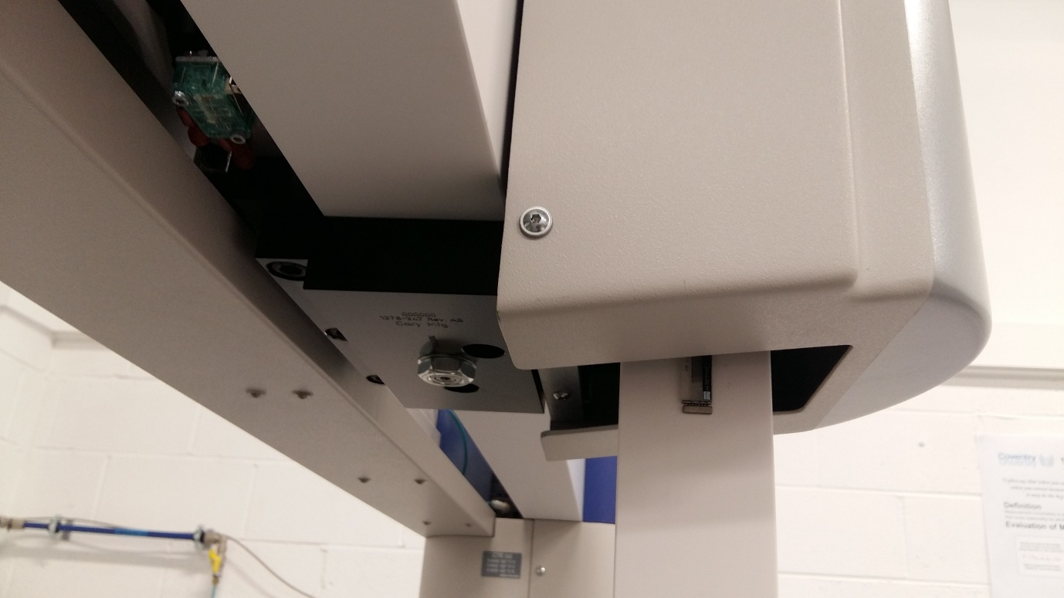**

Axes of movement are done along this line

**Appendix B – Raw data**

*Normal distributions for Sample 47 ab dimensional data:*

**Temperature data**

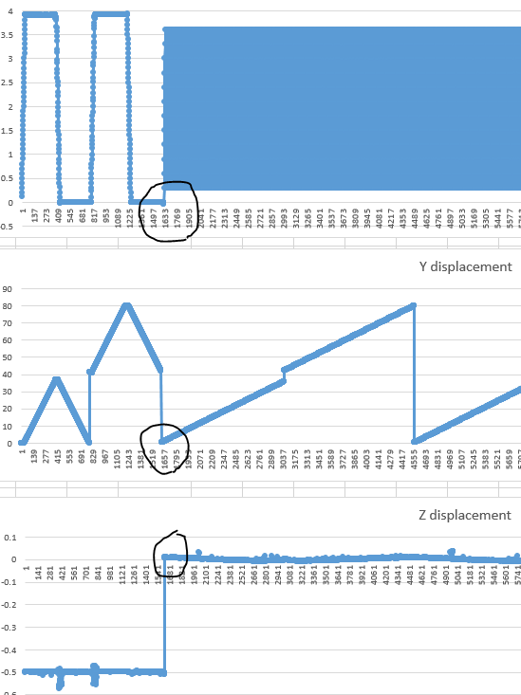

*Figure x: Probe movement change at measurement #1629*

**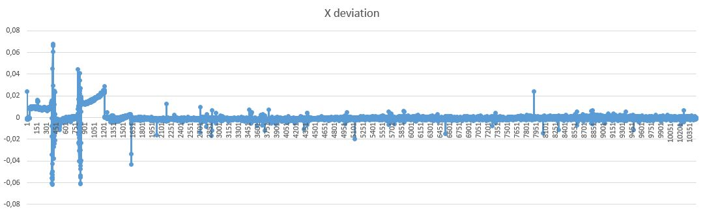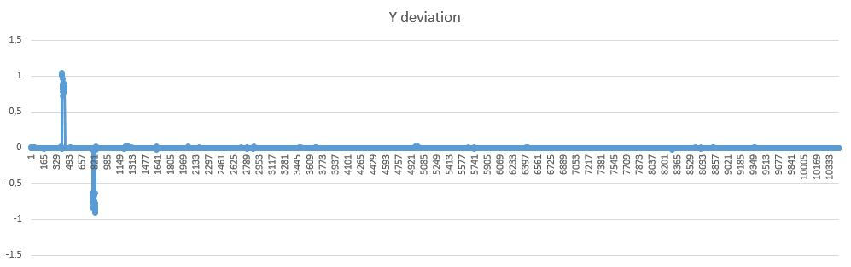**

**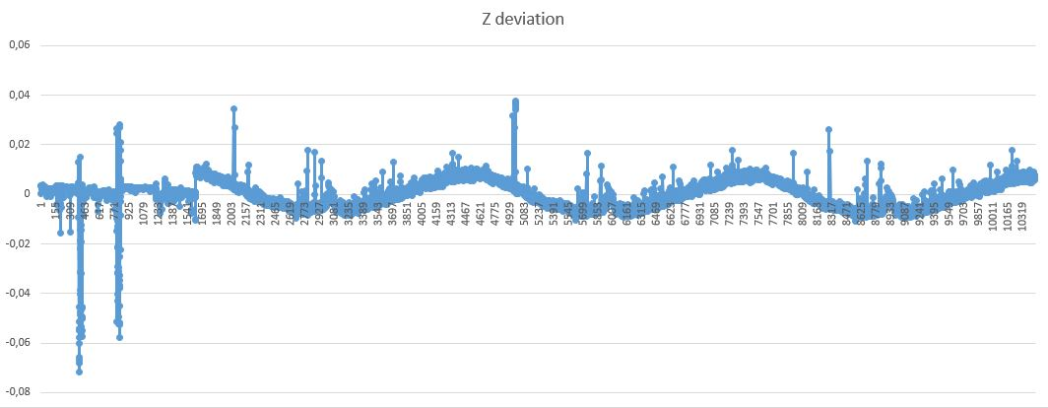**

**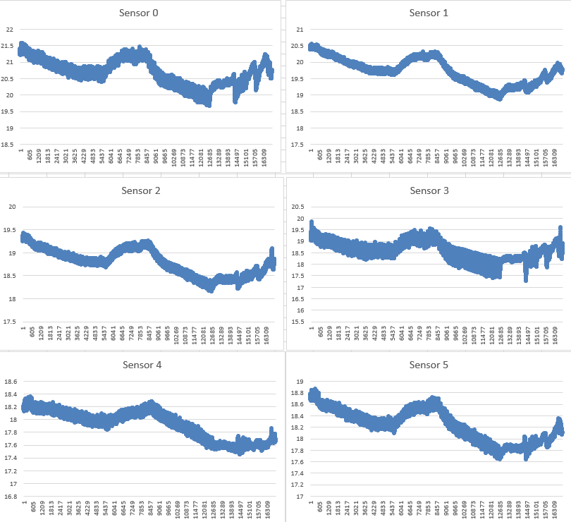**

**Denote max and min**

**Appendix C – Example calculations**

Average X displacement in the initial movement pattern

**Appendix D – References**

[1] Precision Micro. (2019). *Wire EDM - Precision Micro*. [online] Available at: https://www.precisionmicro.com/wire-edm/ [Accessed 4 Mar. 2019]. (edm tolerance 1)

[2] Northwest wire edm. (2019). *Wire EDM - Frequently Asked Questions*. [online] Available at: http://www.northwestwireedm.com/wire\_edm\_faqs.php [Accessed 4 Mar. 2019]. (edm tolerance 2)

[3] The Expression of Uncertainty and Confidence in Measurement. (2012). 3rd ed. [ebook] United Kingdom Accreditation Service. Available at: https://www.ukas.com/download/publications/publications-relating-to-laboratory-accreditation/M3003\_Ed3\_final.pdf [Accessed 10 Mar. 2019]. (UKAS)

[4] Hogan, R. (2019). *Expanded Uncertainty And Coverage Factors for Calculating Uncertainty | isobudgets*. [online] Isobudgets. Available at: https://www.isobudgets.com/expanded-uncertainty-and-coverage-factors-for-calculating-uncertainty/ [Accessed 22 Feb. 2019]. (isobudgets uncertainty)

[5] Gudauskas, B. and Wissner, S. (2012). *An Operator’s Guide to CMM Probe Accuracy*. [online] Qualitydigest.com. Available at: https://www.qualitydigest.com/inside/metrology-article/operator-s-guide-cmm-probe-accuracy.html [Accessed 7 Mar. 2019]. (+- sphericity mm)

[6] Iso.org. (2019). *GUM - English - Annex G. Degrees of freedom and levels of confidence*. [online] Available at: https://www.iso.org/sites/JCGM/GUM/JCGM100/C045315e-html/C045315e\_FILES/MAIN\_C045315e/AG\_e.html [Accessed 10 Mar. 2019]. (k=1.96 source)

[7] Working Group 1 of the Joint Committee for Guides in Metrology (1995). *Evaluation of measurement data - Guide to the expression of uncertainty in measurement*, [online] 1. Available at: https://www.bipm.org/utils/common/documents/jcgm/JCGM\_100\_2008\_E.pdf [Accessed 10 Feb. 2019]. (iso gum)

[8] <https://www.zeiss.co.uk/metrology/products/systems/coordinate-measuring-machines/bridge-type-cmms/contura.html#technicaldata> (our specific cmm)

<https://locate.coventry.ac.uk/primo-explore/fulldisplay?docid=COV_ALMA5147660850002011&context=L&vid=COV_VU1&lang=en_US&search_scope=LSCOP_COV&adaptor=Local%20Search%20Engine&isFrbr=true&tab=local&query=any,contains,uncertainty&sortby=date&facet=frbrgroupid,include,38053900&offset=0> (measurement uncertainty and probability)

[*https://www.dummies.com/education/math/statistics/how-to-calculate-the-margin-of-error-for-a-sample-proportion/*](https://www.dummies.com/education/math/statistics/how-to-calculate-the-margin-of-error-for-a-sample-proportion/) *(sampling)*

Willink, R. (2013). *Measurement uncertainty and probability*. Cambridge: Cambridge University Press.

Add literature review sources and look into them again and add the lit review conclusions to the report

<https://www.ukas.com/services/technical-services/technical-articles/1250-2/> uncertainty theory

<http://publications.npl.co.uk/npl_web/pdf/mgpg42.pdf> (ball)

<https://www.isobudgets.com/type-a-and-type-b-uncertainty/> (type a and b)

<https://www.tandfonline.com/doi/pdf/10.1080/00207540210133435> (main source sampling)

<https://www.isobudgets.com/how-to-perform-a-repeatability-test/> (repeatability)

<https://www2.southeastern.edu/Academics/Faculty/rallain/plab194/error.html> (uncertainty calculation examples)

<http://www.selectcalibration.ca/articles/cmm_uncertainty_budget.pdf>

<https://www.dit.ie/media/physics/documents/GPG11.pdf>

<https://www.ncbi.nlm.nih.gov/pubmed/14564287> (thermal expansion value)

Things to research

Check for GD and T dimensioning and tolerancing